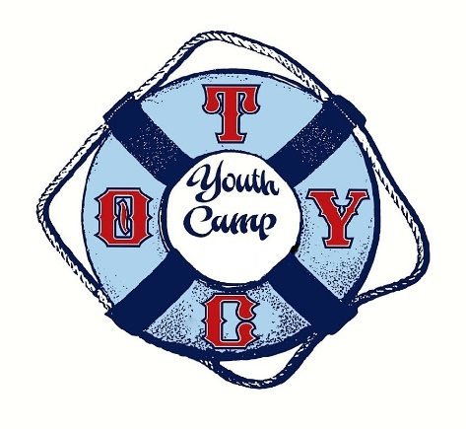
OTYC Youth Camp
Held rain or Shine from 10 a.m. - 1 p.m.
For ages 6 - 15
For generations, the Omena Traverse Yacht Club on Omena Bay has served the community with a half-day youth program in sailing and tennis. Today the tradition continues and you can join the fun - OTYC members and non-members alike! This is a wonderful opportunity to learn new things, make some new friends and enjoy one of the most special places on Earth - our own Omena Bay!
Space is limited so reserve your spot soon. Registration Questions? Contact Linda McKenzie at lindarmckenzie@yahoo.com. INDICATE WHICH WEEKS CHILD WILL ATTEND BELOW:
  - July 2-6 “America” (no camp July 4th)
  - July 9-13 “Science Week”
  - July 16-20 “Color Battle”
  - July 23-27 “Pirate Week”
  - July 30 – Aug 3 TBD (tentative based on enrollment/staffing)

Members - (must be parents, not grandparents)
$130 per week per child
$120 per week per child if registered before June 16th
***For Week 1 ONLY subtract $25 (since it is only 4 days in length)
Non-Members
$150 per week per child
$140 per week per child if registered before June 16th
***For Week 1 ONLY subtract $30 (since it is only 4 days in length)
Drop-In
$35 per day
Check interested weeks above and complete below:

child’s name(s) ______________________________________________

parent name/cell# ______________________________________________

parent email ______________________________________________

**CAMPERS MUST COME TO CAMP WITH A PROPER FITTING LIFEJACKET & TENNIS RAQUET

Mail form & check (made out to “OTYC”) to:
Linda McKenzie
729 Washington Avenue
Wilmette, IL 60091 See you this summer!
OTYC Youth Camp Co-Chairs:
Linda McKenzie & Sara Goldman

